Proposal for Establishment of American Chestnut Groves in Public Parks and Public Sites in Louisville Kentucky

American chestnut was the premier hardwood tree of the Eastern forest, providing a dependable yearly crop of edible nutritious nuts valued by humans, livestock and wildlife, and providing a highly rot resistant timber. From 1904, starting in New York, until the 1940s in Appalachia (including Kentucky), all chestnut was essentially eliminated from the original range by an imported Asian chestnut blight. Extensive efforts to create blight resistant trees through classic plant breeding (The American Chestnut Foundation) and genetic engineering (Cornell and the Forest Health Initiative) are beginning to have success and blight-resistant seedlings from these programs are becoming available for testing. In addition, a second scientific effort to address problems in the South with the root rot disease caused by Phytophthora cinnamomi (ink disease) is making progress.

Establishing groves of American chestnut in proximity to urban populations, like Louisville, serves to:

- Expand urban forest diversity at a time when a number of other important native tree species are under threat. Ash, hemlock, and black walnut have new pathogen problems that may eliminate these trees in our environment, and Sugar Maple (and maples in general) will experience decline as global warming stresses increase. Chestnut was an important part of the previous urban forest, and remains so in Europe. If it can be planted in the proper setting, it will add rapidly to canopy coverage. It is more rapidly growing than Tulip Poplar, and has an upright habit with high crown and excellent wind throw resistance.
- Add an important nut source to the Sustainable and Community Garden movement. Chestnutting was a favorite fall recreational activity prior to virtual extinction of the American chestnut. The American Chestnut Foundation has been recognized with an award by the Slow Food movement in 2005 for its work on preserving the biodiversity of this important culinary resource. KY TACF is also working with local growers in the CSA program to return chestnut to the market place.
- Enhance awareness of the importance of native plants, and of trees in particular. Even people who understand the economic and ecological and culinary importance of chestnut need to encounter the actual tree, and often feel inspired when they do so. Most of people who have direct experience of the American chestnut are now in their 80s and creating a new generation that values this great keystone species requires direct personal experiences. Exposing our “nature-deprived population” to the tree will serve an important educational purpose. It is true that American chestnut was not a major component of the forest in Jefferson County and that we are not in the “historic range” but we have the audience here that can learn to value our native diversity and participate in the return of our greatest tree, just as our urban population enjoys the return of the Bald Eagle.

Goals: Initial establishment of permanent American chestnut groves, consisting of 5-10 mature trees that reach fruiting age. Groves will be planted over a period of five years and include pure American chestnuts as well as advanced 15/16th hybrids with blight resistance. These groves should be publicly accessible in order to increase public consciousness and appreciation for this American legacy tree and to educate the public about ecological issues, such as threats to forest health by imported pathogens and efforts to maintain and restore important keystone species. When productive, these groves will allow people participate in and appreciate “chestnutting” as a family fall activity. Restoring chestnut can be an important element in wildlife habitat improvement and improving the quality of managed urban forests in such natural areas management. (See Chestnutting pages).

Features of American chestnut that will affect establishment success:

- American chestnut is self-infertile, and good nut production requires relatively tight proximity of at least two unrelated trees. The greater the diversity within a grove the better the productivity. Initial flowering can be expected at 7 years of age in well-grown trees in full sun.
- American chestnut requires excellent drainage and prefer acidic soils, but can be drought sensitive in the initial 3-4 years of establishment. It will not tolerate flood plain sites and typically grows where white pine and Northern red oak can be or is established. Potential sites can be tested with pure American seedlings to assess for best sites over a two year period (as has been done at the Zoo site.) Local experience suggests that soils where the percentage of clay is less than 30% are possible sites for establishing chestnut.
- American chestnut is fast-growing , often growing at 3 ft per year after the first year. Direct nut seedling is recommended to avoid transfer of nursery related diseases, like Phythophora cinnamoni (ink disease), which is widely present through other Southern sites and tree nurseries.
- Nut and seedling protection is essential through the first 5-7 years, since plantings cannot otherwise be established. Studies show that survival is at best about 2-3% without protection. Seedlings require nut protection (birds, rodents, including raccoons), stem protection (voles), and secure browse protection (rabbit, deer).
- Maintenance, including yearly fertilizer, herbicide application for weed control, mowing and some structural pruning is needed for approximately 5 years after planting nuts, or until apical leader is beyond deer browse height. Chestnut grows poorly in competition with grass, and is not a primary field succession species. A large composted bark mulch circle (4-6 ft in diameter) may also reduce the incidence of Phytophthora root rot.

Project Plan for establishing chestnut groves:

Initial Phase:
Site Selection: Ideal sites would be open, sloped, and adjacent to woodland strips, and not compacted. Ideally the soil should have less than 30% clay in the upper soil horizons, and a depth of more than 48” to the first restrictive layer. They would be publicly accessible in the overall landscape plan, to allow easy maintenance and public participation.
- For larger areas, like Jefferson Memorial Forest, use soil mapping to determine areas where sites may exist based on optimal soil types. So far, test planting have identified Crider Silt Loam, Nicholson and Shelbyville silt loam, Otwell B & C, and Zanesville silt loam as potential soil types compatible with chestnut.
- Establish partnerships with natural areas managers and Historic Homes like Locust Grove and urban units within greater Louisville, like Crescent Hill, Seneca Gardens, and Audubon Park.

Site preparation: Minimum size would provide for initial planting of 5 to12 trees at 8 foot to 10 ft spacing with a 20-30 foot barrier at the edges (from roads and woodland edges.) Configuration of groves would be based on site.
- Clearing and removal of any competing trees and ground cover, particularly invasive plants, e.g. multiflora rose, honeysuckle, porcelain berry, blackberry.
- Air-knifing with 15” air-knife for decompaction of a 6 x 6 ft planting area. Amendment with composted bark.

Test Planting: Either nut planting April-May (or sprouted seedling planting Fall)
- Treat each planting site with RoundUp Herbicide in 4 foot diameter circle, and re- clear site as needed.
- Plant 5-8 pure American chestnut nuts at 6 ft spacing. Nuts are planted with bulb planters and using soil mix. Takes approximately 5 minutes per nut.
- Protection to include: For chestnuts: A tree collar around each nut (BlueX 15” or TreePro double wide at 18”), with individual deer barrier of 4 ft high by 3 ft diameter welded wire barrier (or 4 ft hardware cloth) with 4 stakes. Alternative is to use solar electric deer fencing, such as the QuikDeer net fencing available from Premier 1 Fence (Jefferson Memorial Park.) or Deer Sprays (products like Plantskydd or Deer Scram)
- Mulch with composted hardwood mulch within welded wire barrier.
- Fertilize with Osmocote or other slow-release fertilizer at 6 weeks (before Ooze tube placement.)
- Place 15 or 25 gal Ooze tubes around each chestnut within barrier in May and fill on a two weekly basis with water. Need truck carrier for 125 gallons (5 trees with 25 gallons each).
- Mow every two weeks to three weeks as needed to control grass within planting site.

Planting Materials: American chestnut nuts or seedling would be provided through partnership with the Kentucky Chapter of TACF.

Final Planting:
For sites with good chestnut growth, add advanced blight-resistant American chestnut in third year. Plant as above, with modifications as dictated by test observations. The Meadowview Restoration Chestnuts (B3F3 generation) are valued at $125 per nut and are available in limited numbers through the Kentucky Chapter of the American Chestnut Foundation if the landowner signs the TACF Germplasm Agreement.

Maintenance phase: 4 years
- Remove and store Ooze tubes after first year (most will be reusable)
- Remove BlueXs by year two or three.
- Measure Height & DBH (diameter at breast height) yearly.
- Performance structural and remedial pruning yearly (removal of dead/crossing branches and basal sprouts.)
- Fertilize yearly with Osmocote
- Weed control with Round Up and mow as needed. (By year 5 mowing in immediate vicinity of tree shouldn’t be needed if trees keep lower branches and self-mulch. A 6 ft diameter mulched areas should be maintained.
- Consider treatment for prevention of Phytophthora root rot with Subdue MAXX and Agri-Fos.

Expected Results: Trees of 4-5” diameter and 18 ft height by eight year, with some blooming beginning in fifth year. Mast production should be established by year 10 and expand to large numbers of nuts by year 20.

American chestnuts at the Meades Landing Orchard grown on Crider Silt Loam have reached an average of 12 ft in height at the end of the fourth year of growth, and several trees are 15-18 ft in height. 60% of the trees have started blooming with catkins (male) at both 3 and 4 years. Crider Silt Loam is a major soil for George Rodgers Clark Park, Creason Park, the Louisville Nature Center, and the underlying component of urban soil at the Zoo and in City of Audubon Park.

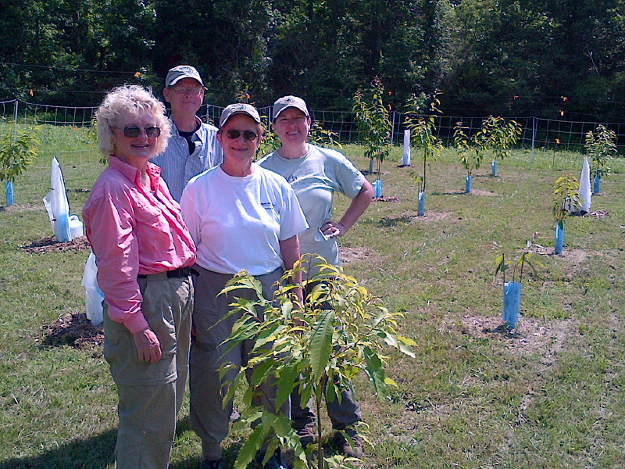
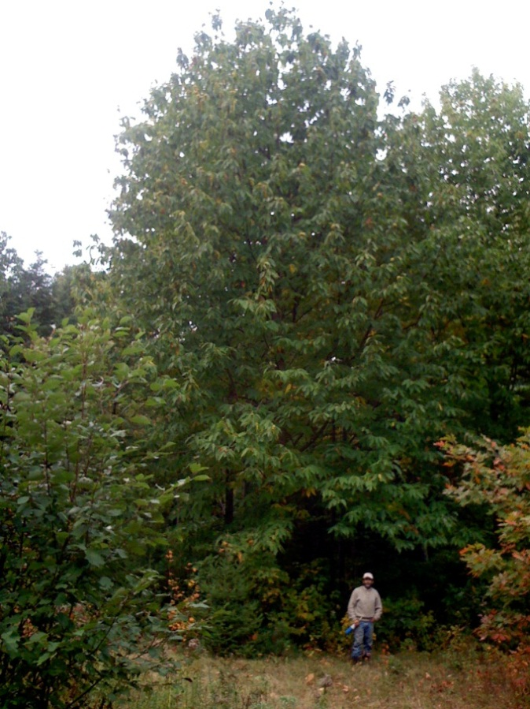
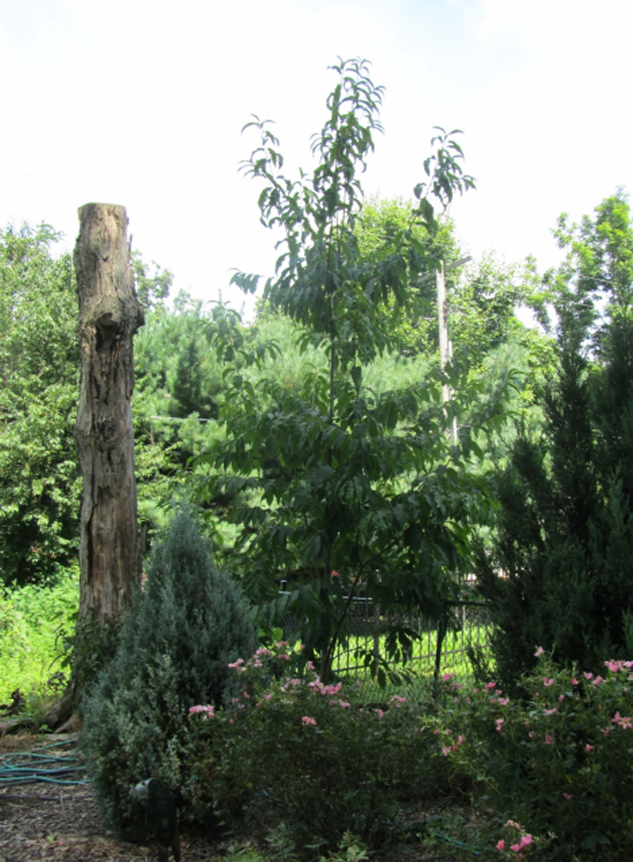
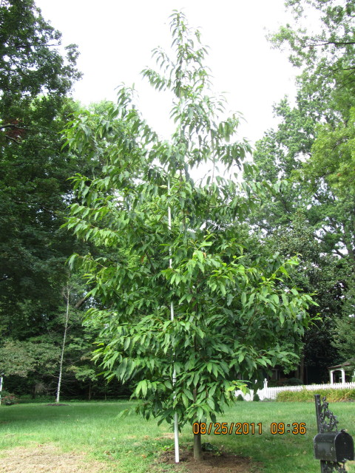
Urban Chestnuts in Louisville Tree on the left - 21 ft tall since 2007. Tree on right is 22.5 ft since 2007.
Above: Jefferson Memorial Forest: 2011 Planting Right: 20 yo tree in Maine
.

